MAKE SKILLED IoT INTERNSHIP

ASSIGNMENT – 15

Automated Drip Irrigation System.

* + HERE WE WILL BE USING ARDUINO INTERFACE.
  + COMPONENTS REQUIRED:
  1. ARDUINO UNO BOARD
  2. PC / LAPTOP INSTALLED WITH ARDUINO IDE SOFTWARE
  3. SOIL MOISTURE SENSOR
  4. JUMPING WIRES
  + CIRCUIT DIAGRA

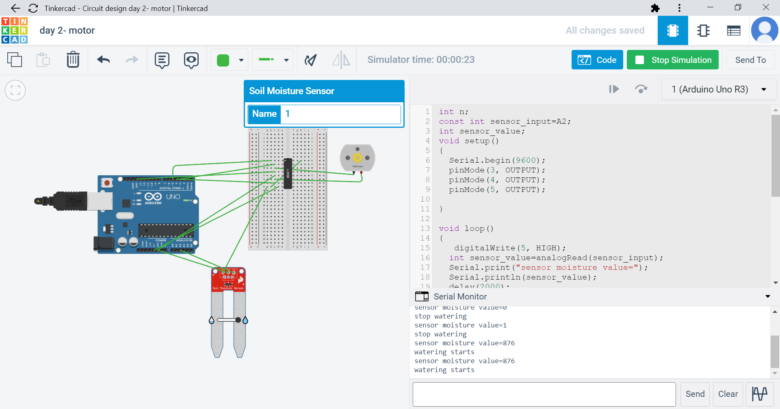

* PROGRAM

const int sensor_input=A2;

int sensor_value;

void setup()

{

Serial.begin(9600);

pinMode(3, OUTPUT);

pinMode(4, OUTPUT);

pinMode(5, OUTPUT);

}

void loop()

{

digitalWrite(5, HIGH);

int sensor_value=analogRead(sensor_input);

Serial.print("sensor moisture value=");

Serial.println(sensor_value);

delay(2000);

if (sensor_value > 200) {

digitalWrite(3, HIGH);

digitalWrite(4, LOW);

Serial.println("watering starts");

}

else {

digitalWrite(3, LOW);

digitalWrite(4, LOW);

Serial.println("stop watering");

}

delay(2000);

}

OUTPUT:



**By Team : AKULA ZAHEER SHA , TAUFEEQ BASHA & QUIZER SHAH**